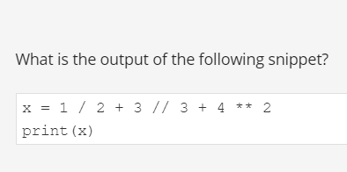

17.5

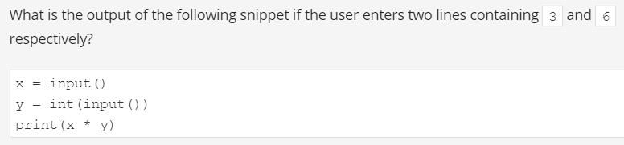

333333

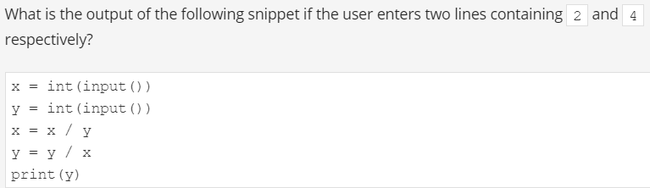

8.0

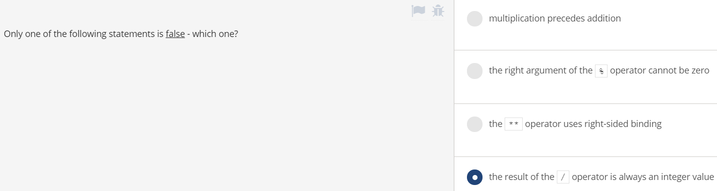

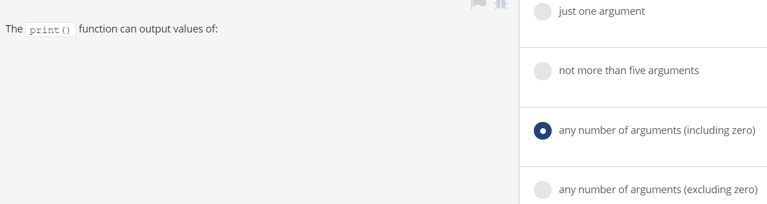

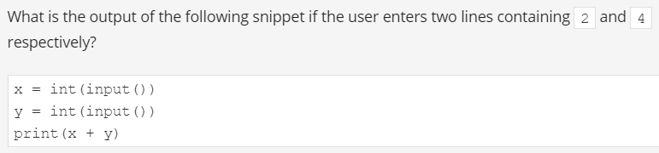

6

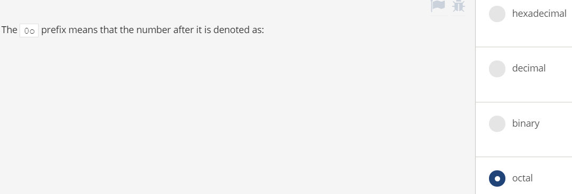

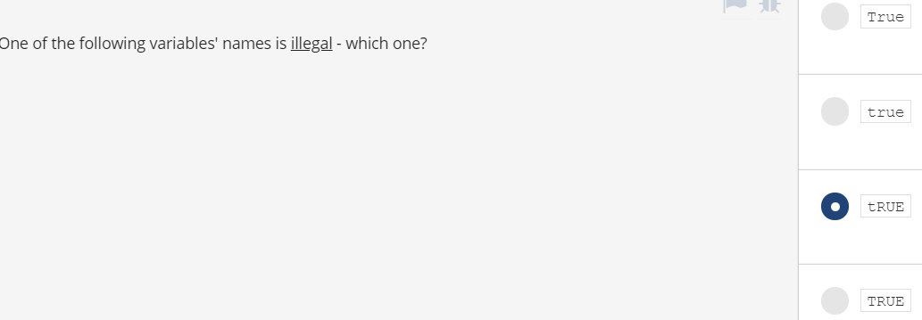

True

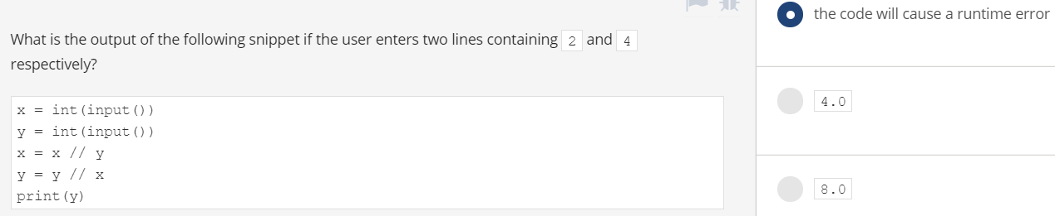

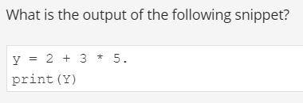

17.0

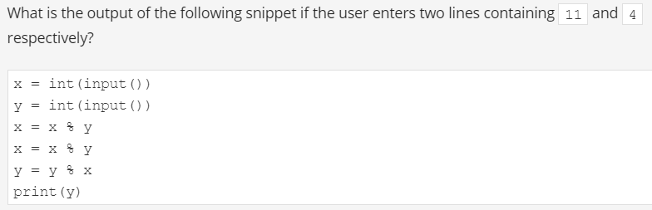

1

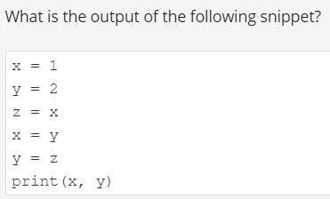

2 1

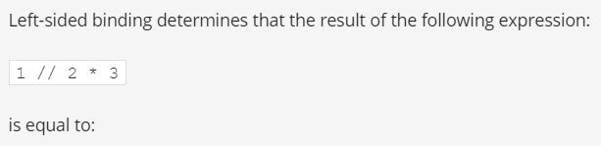

0

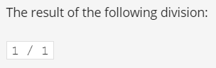

1.0

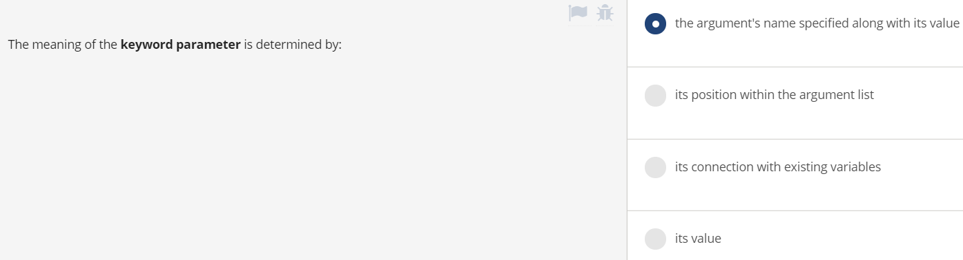

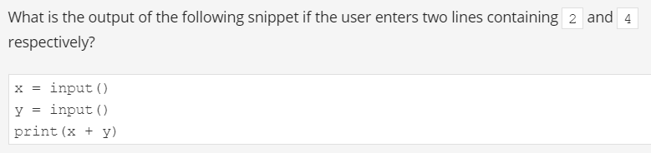

24

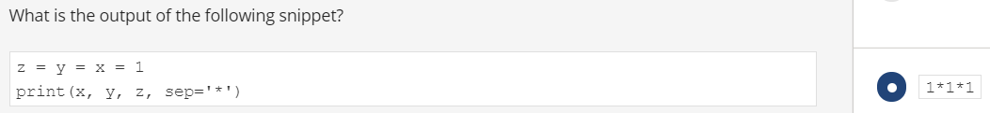



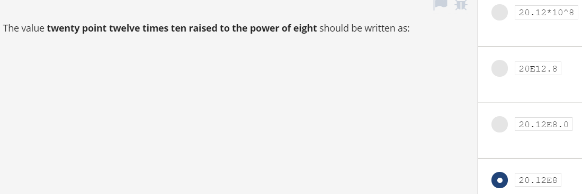

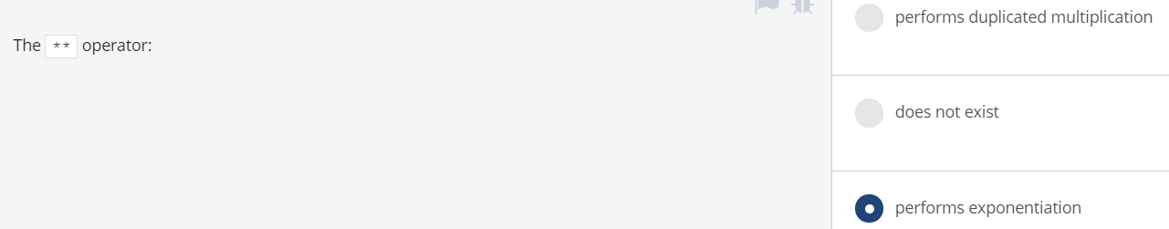

<https://www.premiumexam.net/pcap-programming-essentials-in-python/pcap-programming-essentials-in-python-quizzes-module-1-test-answers/>